**Lab Session 07**Explore Internet-of-things design flow

**Exercises**1. Suppose you are required to design an IOT based system for home intrusion detection. The purpose of the home intrusion detection system is to detect intrusions using sensors (PIR sensors and door sensors) and raise alerts, If necessary. Each room has a PIR motion sensor and each door has door sensor attached to it. Each sensor is read at regular intervals and the motion detection and door opening events are stored and alerts are sent. For the described system, give the following:

**• Purpose & Requirements Specification:**

**Purpose:** A home intrusion detection system that detects intrusions using sensors (PIR sensors and door sensors) and raise alerts, if necessary. **Behaviour:** The home automation system should have auto modes. Each room has a PIR motion sensor and each door has door sensor attached to it. Each sensor is read at regular intervals and the motion detection and door opening events are stored and alerts are sent.  
**System Management Requirement:** The system should provide monitoring and control functions  
**Data Analysis Requirement:** The system should perform local analysis of the data.  
**Application Deployment Requirement:** The application should be deployed locally on the device, but should be accessible remotely.  
**Security Requirement:** The system should have basic user authentication capability.

• Process Specification

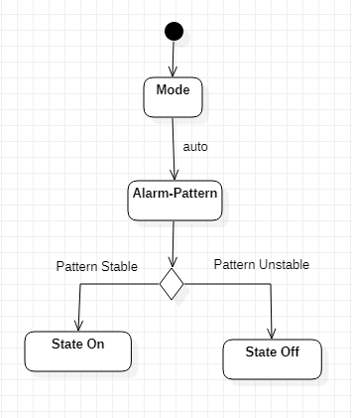

• Domain Model Specification

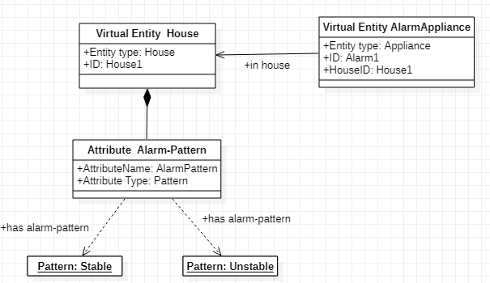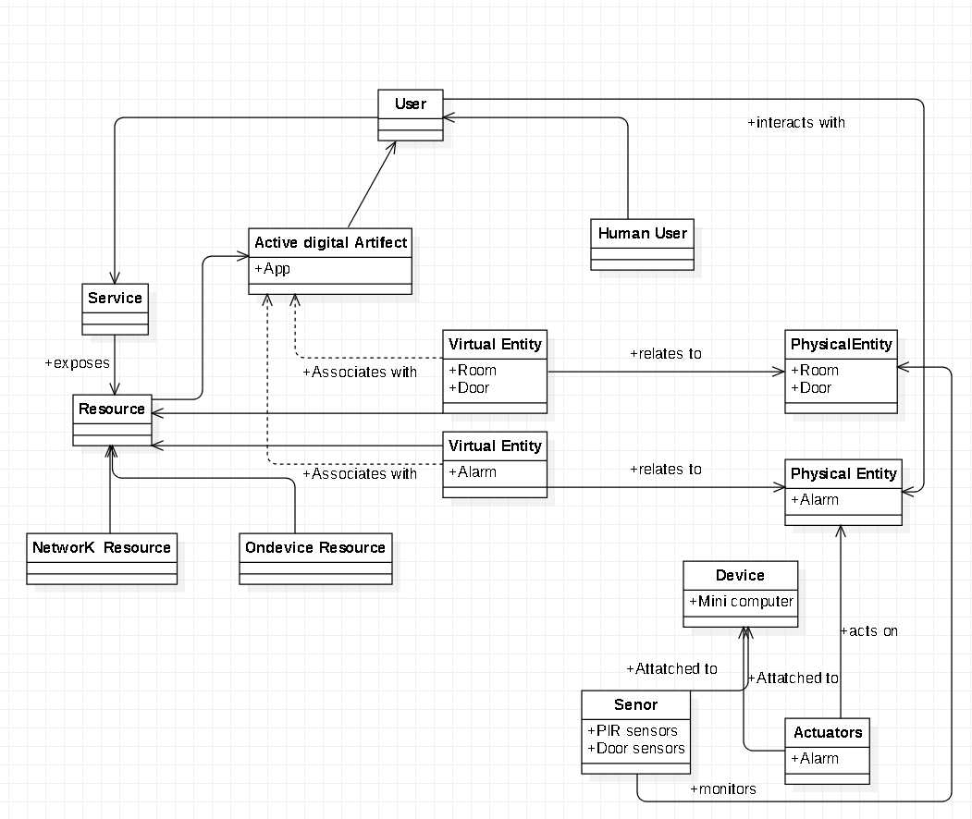• Information Model Specification

• Service Specifications